 | Price for Bozon devices and auxiliary devices,  accessories and material  Medical ozone generators in the world produce only gaseous ozone-oxygen mixture. The Bozon generators are totally different because they provide six automated procedures for the practice of ozonetherapy: These procedures are:  MAHT  Minor MAHT  Rectal Insufflation  Vaginal Insufflation  Intravenous injection of ozonated saline solution  Ozonated Water  Ozonated Oil
The Bozon family is unique in the world of medical ozone generators which has a double format of measurement of concentration of ozone in ozone-oxygen mixture and water environments (the distilled water, saline solution). Family Bozon devices have a built in measuring instruments of speed of a stream of gas, pressure of gas and concentration of ozone in gas and water. All of the generators are automated.

Technical characteristics ozonetherapeutical device Bozon
Kinds of supported procedures | Autohemotherapy major, Autohemotherapy minor, intravenous infusion ozonated saline solution, Preparation of ozonated water and ozonated oil, rectal and vaginal insufflation, application ozone on skin hand and foot, subcutaneous injection of ozone.
Way of installation of initial parametres (concentration of ozone in gas, or a saline solution, speed of a stream of gas, volume and procedure time) | digital form built in keyboard or remote panel.
Form of measurement of a concentration of ozone in gas and water | UV- photometric
Form of measurement of the flow and pressure of gas | semi-conductor differential manometer
Stabilisation of parametres of procedure | program
Range of concentration of ozone in an ozono-oxygen mix | 0.5 – 120 mg/litre
Relative error of measurement of concentration of ozone in an ozono-oxygen mix | <10%
Range of concentration of ozone in water | 0.5-30 mg/litre
Relative error of measurement of concentration of ozone in an ozono-oxygen mix | <10%
Range of speed of a stream ozono-oxygen on a device exit | 0.1 – 2 litre/ min
Relative error of measurement of speed of a stream of an ozono-oxygen mix | < 10%
Productivity of the device gramme/hour | >6 gramm/hour
Pressure of oxygen upon a device input | 0,15-0,2 mPa
Service life of a reactor of the generator of ozone | > 10000 hour
Power consumption | <150 watt
The sizes of the device | 350*110*450
Device weight | 8 kg

Functionality and metrology, advantages ozonetherapeutical device Bozon
Kind of ozonetherapy procedure | Feature of Bozone-N device |  |  | Features of the best world samples of devices for ozonetherapy
Kind of ozonetherapy procedure | Metrology |  | automatic | metrology | automatic
Autohemotherapy major | conc.O₃  in gas | full | full | full | full
Autohemotherapy major | doze O₃ | Full | full | Manual calculate | none
Autohemotherapy major | blood | Blood exit
Autohemotherapy major | blood | Blood returning
Ozonated saline solution | conc.O₃  in gas | full | full | full | full
Ozonated saline solution | conc.O₃  in saline solution | At a preparation stage | Exact demanded value | full Only one manufacturer in the world (Medozon, Russia) | none
Ozonated saline solution | conc.O₃  in saline solution | During intravenous procedure | Maintenance of exact value during all time of procedure | none | none
Preparing ozonated oil | conc.O₃  in gas | full | full | full | full
Preparing ozonated oil | conc.O₃  in oil | Calculation under the empirical formula | full | none | none
Preparing ozonated water | conc.O3  in gas | full | full | full | full
Preparing ozonated water | conc.O3  in water | full | full | Full Only one manufacturer in the world (Medozon, Russia) | none
Rectal and vaginal insufflation | conc.O3  in gas | full | full | full | full
Rectal and vaginal insufflation | flow | full | full | full | none
Rectal and vaginal insufflation | volume | full | full | Manual calculate | none
Processing of ozone of a surface on a skin in plastic containers | conc.O3  in gas | full | full | full | full
 | flow | full | full | full | none
 | volume | full | full | Manual calculate | none

Ozone therapeutic device "Bozon-EBOO-RU"

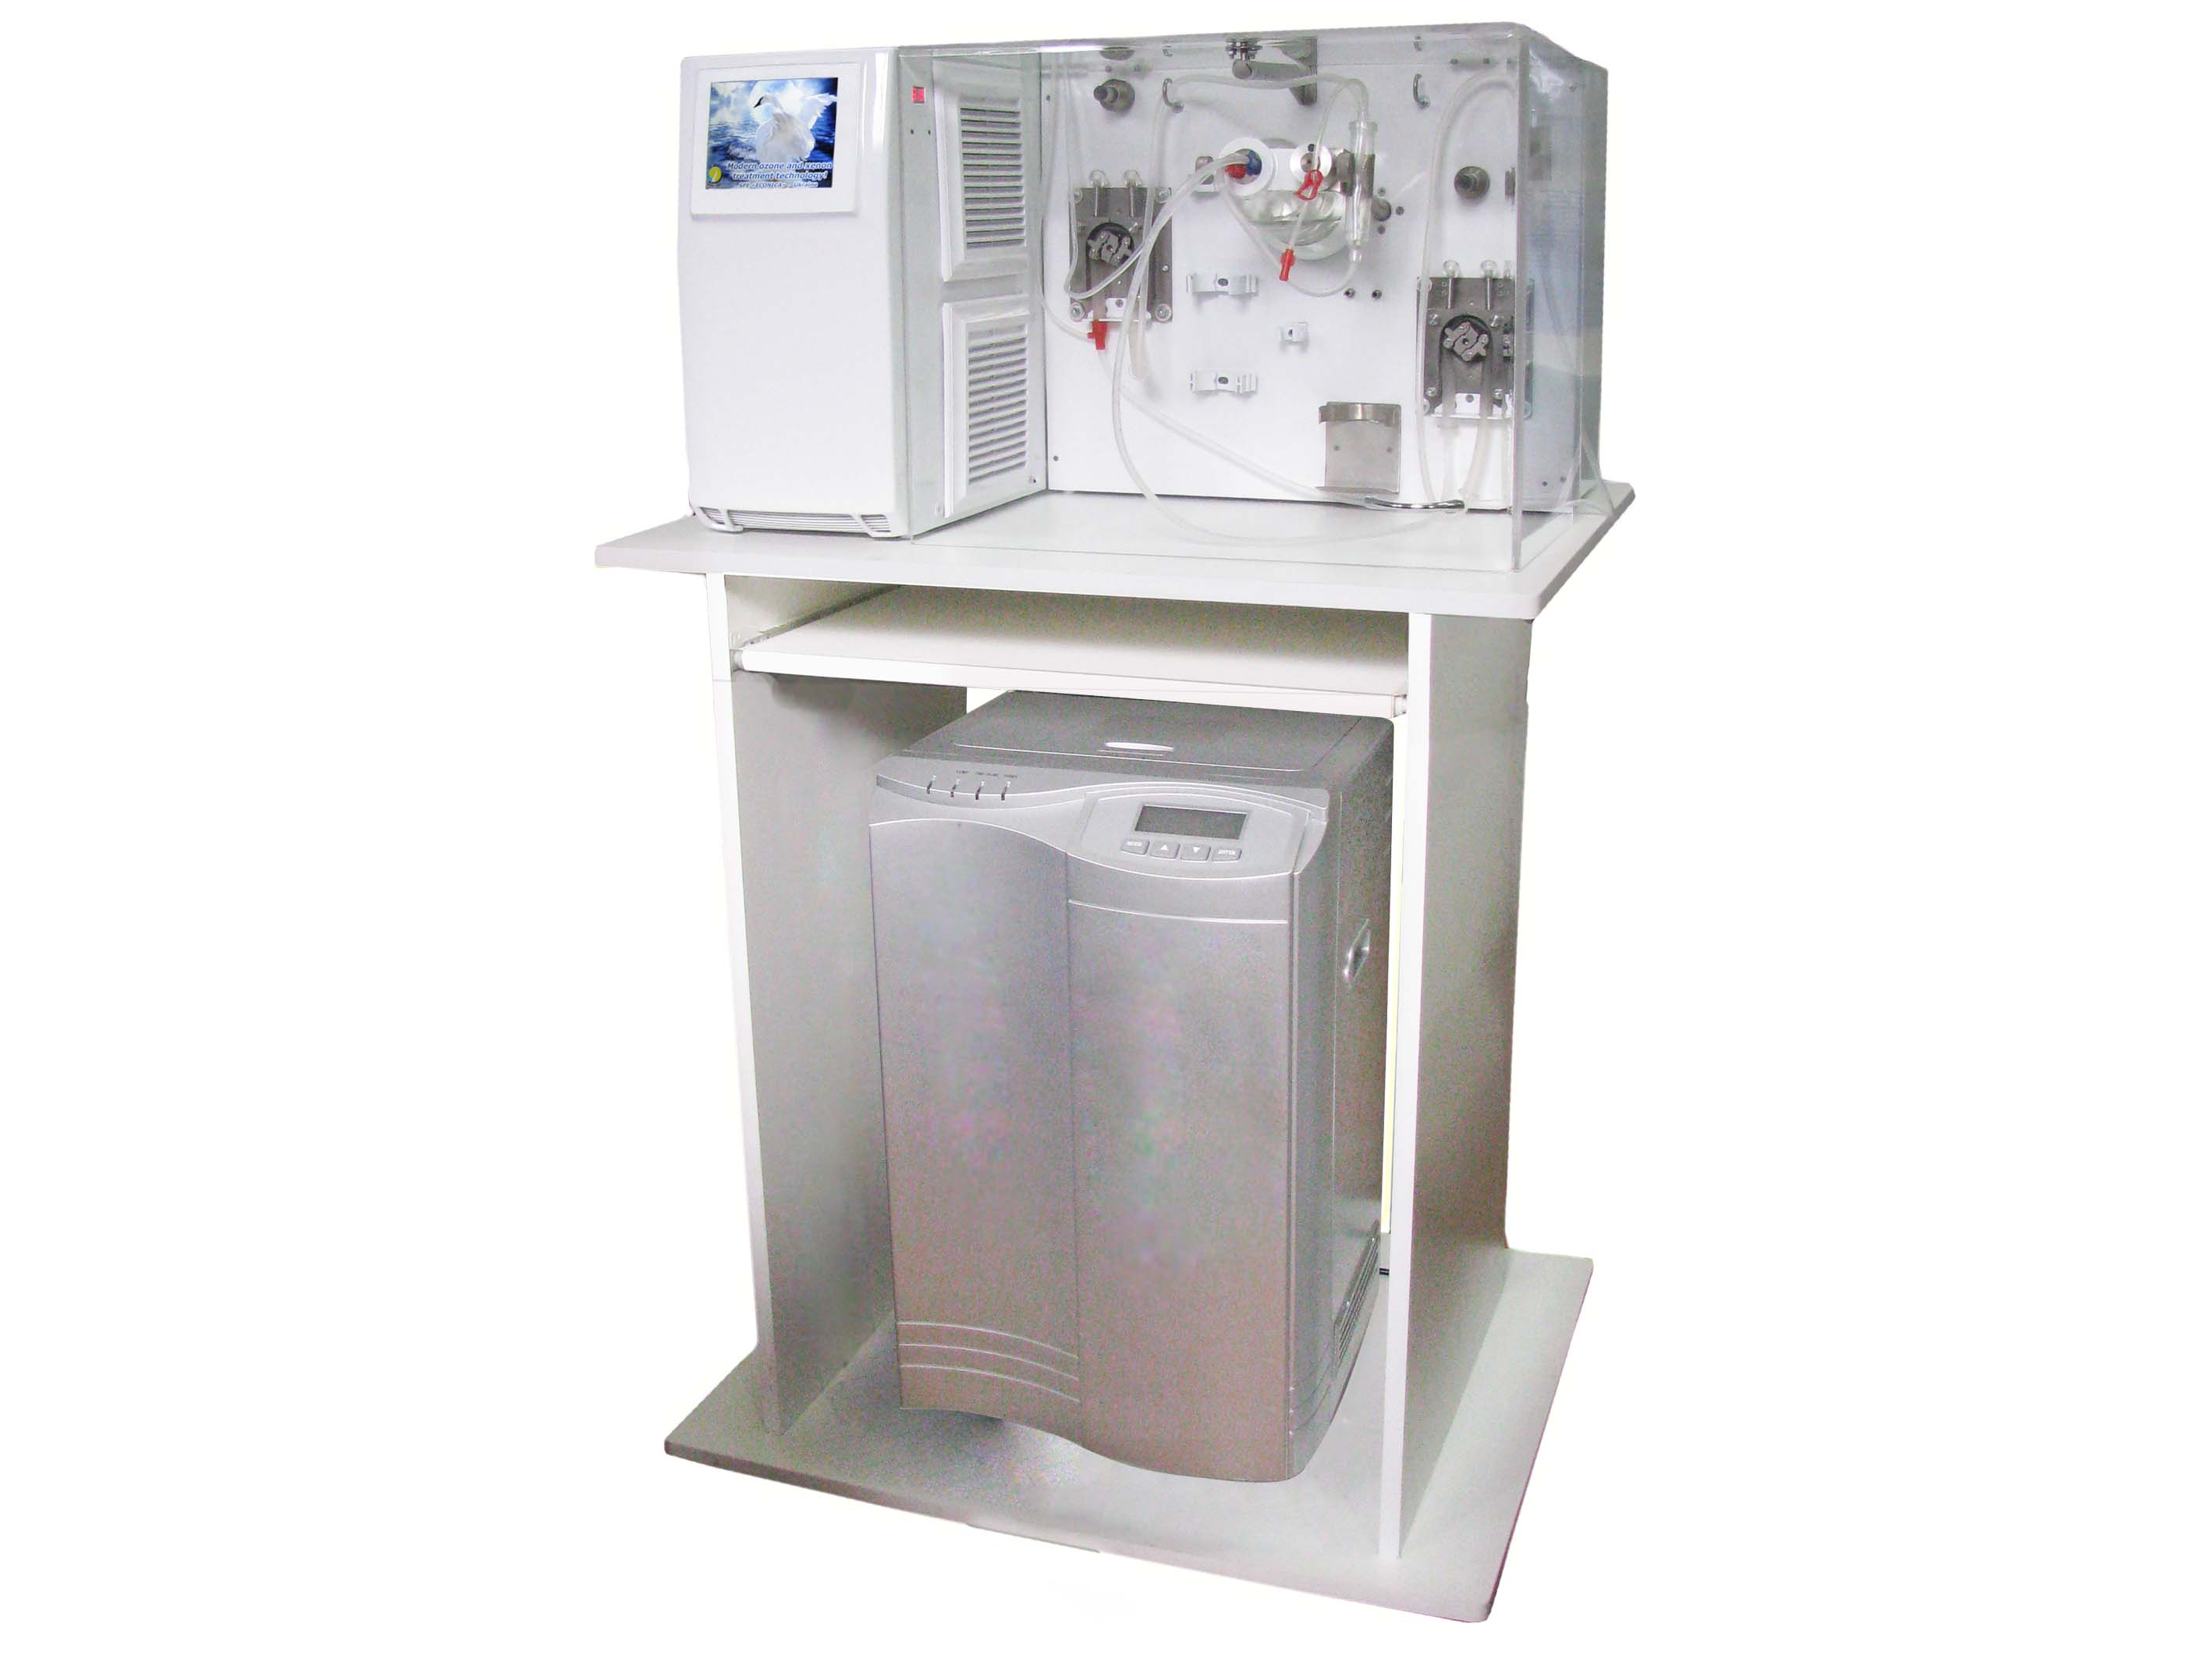 | Installation for extracorporeal blood processing ozone-oxygen mixture Bozon-N- EBOO RU. EBOO processing performed on the patented method consists in computer controlled, the interaction of ozone-oxygen mixture, and blood in the revolving thin layer of blood, which is formed in a rotating glass rotary-film contactor. The procedure of processing the total blood volume depends on the caliber used in the veins. When using the cubital vein, while full treatment of circulating blood (5 liters) of 2-2.5 hours.  The device has a built-in source of oxygen. The device can also be used as a medical ozone generator for general purpose. The device has a built-in measuring concentration of ozone in the gas phase and in the aqueous phase. Ozone concentration and the gas flow is established and maintained automatically within 0.5-100 micrograms / ml at a flow of gas 0.2-1 liter / minute.  Price for distributors : 21950 $.

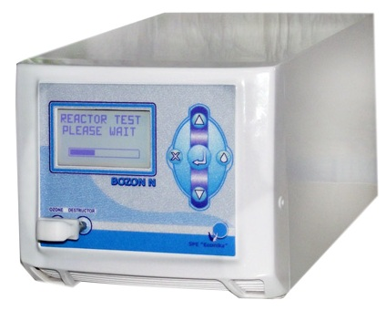  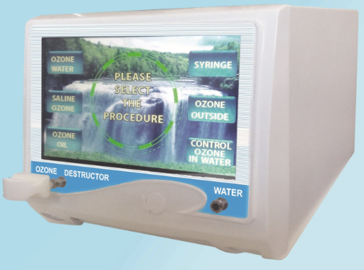  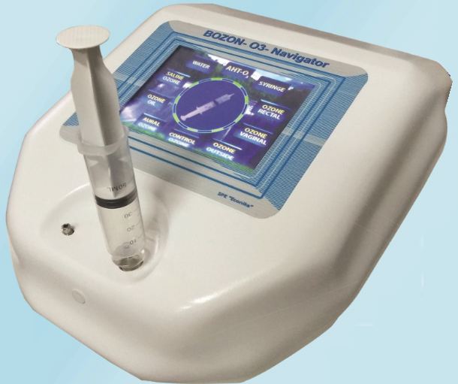  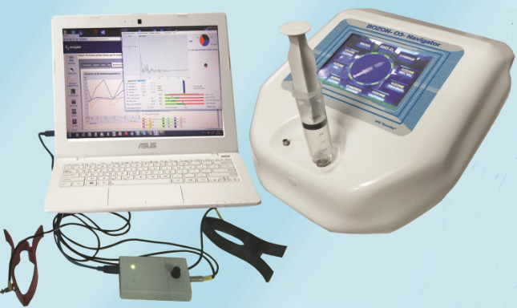 | Ozone thera Ozone therapeutic device "Bozon-N"  The device is fully automated and has two channels for measuring the concentration of ozone in a gas mixture and in aqueous media - distilled water and an ozone-oxygen gas mixture. The software of the device allows you to automatically perform the following procedures: 1) fill a syringe with a volume of 5 to 100 ml of ozone-oxygen mixture with a concentration of -0.5-100 mcg / ml, 2) generate an ozone-oxygen mixture stream with a flow from 0.2 to 1000 ml / min and concentration from 0.5 to 100 micrograms / ml in non-stop mode,  Price for disPrice for ditributors: 3200 $.  Ozone therapeutic device "Bozon-N+"  The device is fully automated and has two channels for measuring the concentration of ozone in a gas mixture and in aqueous media - distilled water and an ozone-oxygen gas mixture. The software of the device allows you to automatically perform the following procedures: 1) fill a syringe with a volume of 5 to 100 ml of ozone-oxygen mixture with a concentration of -0.5-100 mcg / ml, 2) generate an ozone-oxygen mixture stream with a flow from 0.2 to 1000 ml / min and concentration from 0.5 to 100 micrograms / ml in non-stop mode, 3) prepare ozonated water with a preset ozone concentration in the range from 1 to 30 μg / ml, 4) prepare ozonated saline solution with a preset ozone concentration in the range from 0.1 to 5 μg / ml, 5) ozonize oil to a specified peroxide value within 50 to 2,400 units . If the Wi-Fi is available at the place of operation of the device, all the time the device is under Internet control from the manufacturer.  Price for distributors: 3700 $.  Ozone therapeutic device "Bozon-N++"  The device is fully automated and has two channels for measuring the concentration of ozone in a gas mixture and in aqueous media - distilled water and an ozone-oxygen gas mixture. The software of the device allows you to automatically perform the following procedures: 1) fill a syringe with a volume of 5 to 100 ml of ozone-oxygen mixture with a concentration of -0.5-100 mcg / ml, 2) generate an ozone-oxygen mixture stream with a flow from 0.2 to 1000 ml / min and concentration from 0.5 to 100 micrograms / ml in non-stop mode, 3) prepare ozonated water with a preset ozone concentration in the range from 1 to 30 μg / ml, 4) prepare ozonated saline solution with a preset ozone concentration in the range from 0.1 to 5 μg / ml, 5) ozonize oil to a specified peroxide value within 50 to 2,400 units. The device is equipped with a vacuum pump that allows ozone suction from the bag during the procedure of application of ozone on skin (ozone bagging) or vacuum massage. . If the Wi-Fi is available at the place of operation of the device, all the time the device is under Internet control from the manufacturer.  Price for distributors: 4500 $.  The automated workplace of the doctor of the ozone therapist “Bozon-N-WEB + O3Test + O3Navigator”  The workplace includes the advance version of the ozone generator of the Bozon family and computerized automation tools for the ozone therapist. The computer facilities are based on the use of the O3Navigator program, which includes an online database of patients and a database of ozone therapy protocols. In addition, the O3 Navigator program has a subroutine for assessing the effectiveness of the ozone therapy course. As data for assessing the dynamics of the course of ozone therapy, the data on the cardio intervalogram of the patient are used. This method is similar to the method of Chinese pulse diagnosis and allows you to conduct a scientifically based treatment course that guarantees adaptive rejuvenation of the body .  Price for distributors: 4900 $.
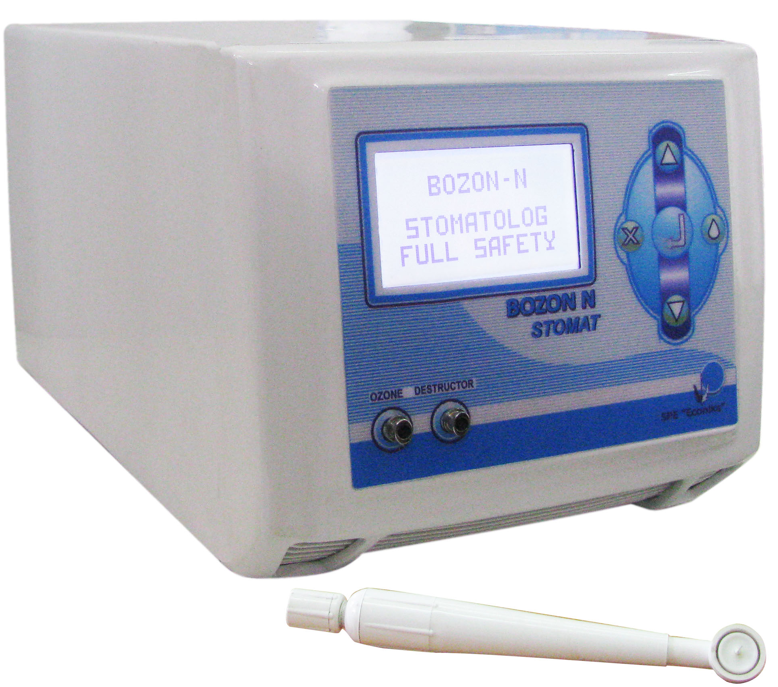 | Ozone therapeutic device "Bozon-N-STOMAT "  The unit is designed to work with the dental attachment for gas processing and fissures of the tooth, tooth caries lesions, root canal disinfection in the treatment of angular hielitis and periodontal disease. This mode is used for the production of ozone oxygen container with built-in Settings range of ozone concentrations 4-40 mg / liter.  The unit provides preparation of ozonized distilled water, which is used for drinking, sanitation oral channels, to increase local immunity, to relieve inflammation of the gums and periodontal after dental operations to prevent sores. This mode is used for the production of ozone oxygen with built-in containerplants or from the air.  Special module provides sterilization of medical instruments. This mode is used for the production of ozone oxygen with built-in container plants or from the air.  In the sanitation and disinfection of workplace air of a dentist during an intense emission of harmful substances.  Technical data  1. The range of concentration of ozone in the gas codental attachment  1. The range of concentration of ozone in the gas codental attachment  The maximum amount of oxygen in the embedded container - 2n  The rate of ozone suction during dental procedures2l/min.  Opening hours on one charge built container - 2.5 hours.  The plant capacity 100 W  Measurement error of ± 20%  Price for distributors: 3200 $.
  Regime of work:
  Low | 4,6…..6,0 mg/L
  Mıd | 12,5…..13,8 mg/L
  Max | 33,1…..37,6 mg/L
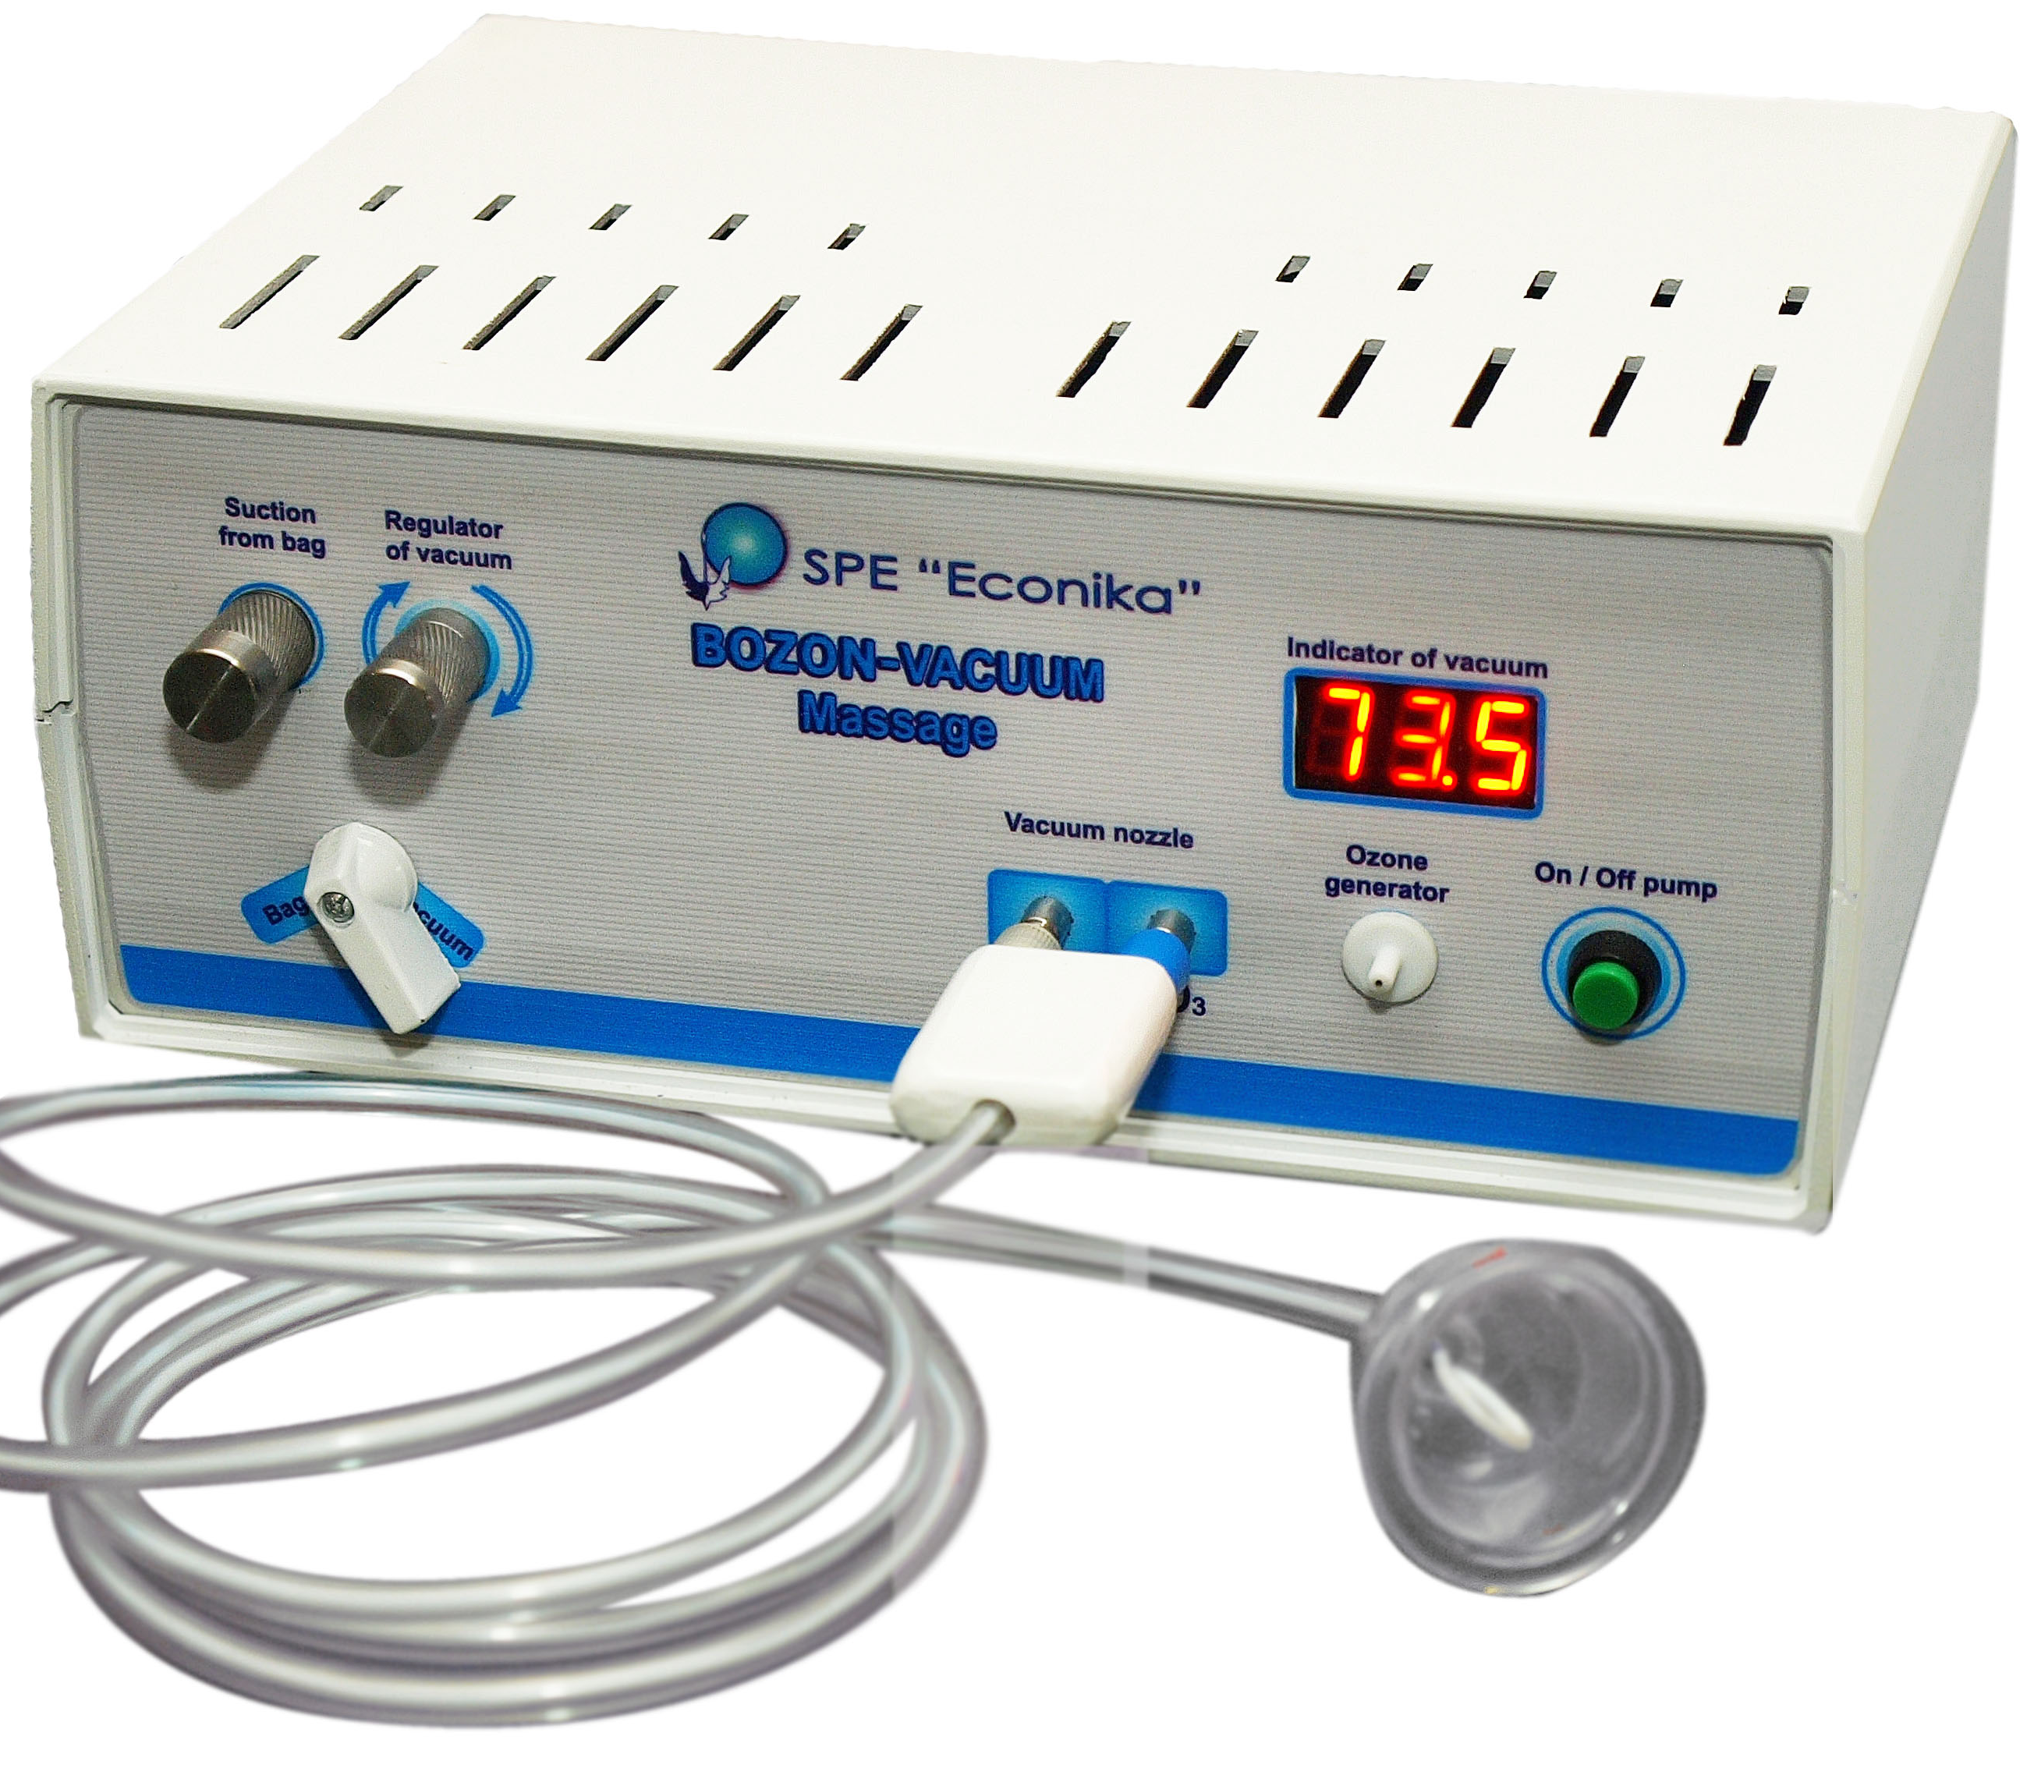 | Module "Bozon VACUUM Massage”  This module is designed for vacuum massage with ozone. A set of four special glass nozzle can handle all sizes of problem areas of the body. Stepless adjustment of the vacuum is adjusted individually depending on the threshold of sensitivity of the patient.  An additional feature of the module - ozone suction mode with a bag in cases of external applications of ozone.  Price for distributors: 900 $.
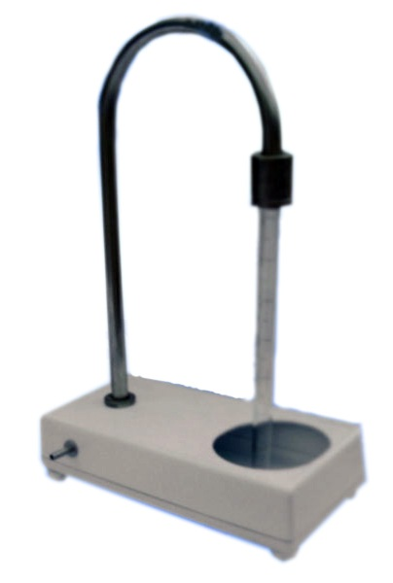  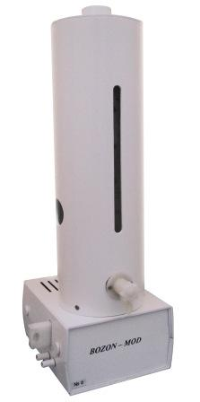 | Module "Bozon MOO”  Is used for preparation of the ozonized oil in the module MOO.  Price for distributors: 70 $.  Module "Bozon MOD”  Complete set:  The device is intended for preparation of the ozonized distilled water with the known concentration.  Price for distributors: 200$.
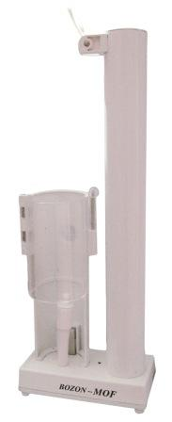 | Module "Bozon MOF"  Complete set:  Device is intended for measuring ozone concentration in the salin solution during the OPhS preparation and maintenance of the concentration during conducting intravenous infusion of the ozonized salin solution.  Price for distributors: 180 $.
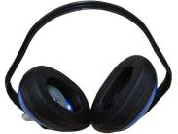 | Module "Bozon-LOR"  Complete set:  The Module "BOZON-LOR" is a device for ozone therapy of otitis, maxillary sinusitis by a method of ozone application inside the ear by catalytic deozonator. It allows to make application of ozone- oxygen mixture inside the ear at high concentration (10-100mg/l) without air pollution of a premise by ozone.  Price for distributors: 100 $.
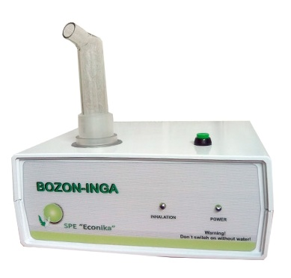 | Module "Bozon-INGA"  Complete set:  The Module "BOZON-INGA" is intended for inhalation of ultrasonic hydrosol of ozonides.  Price for distributors: 600 $.
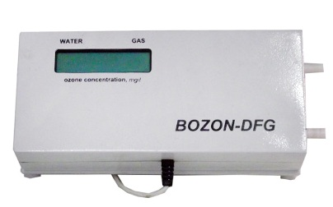 | Measuring instrument "Bozon-DFG”  Complete set:  The measuring instrument "BOZON-DFG" is intended for measurement of ozone concentration in gas, salin solution and distillate.  Price for distributors: 1100 $.
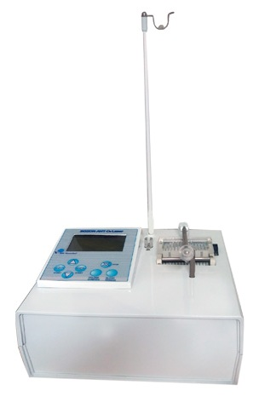 | Module "Bozon-BAGTO-LAZER"  Complete set:  The Module "BOZON-BAGTO-LAZER" is an automated device for carrying out big autohemotherapy. There is a reverse peristaltic pump with the executive mechanism of cam type and a microprocessor control system. The application of the module "BOZON-BAGTO-LAZER" considerably (up to four times) reduces time of conducting the procedure. It sharply reduces traumatism of BAHT procedures due to the use of a 0.7 mm needle for taking blood. The device has the built in regulator of blood flow velocity, the timer and safety system preventing the possibility of air breakthrough into the vein during reinfusion of the ozonized blood. It is protected by patents of Ukraine and Russia  Price for distributors: 1500 $.
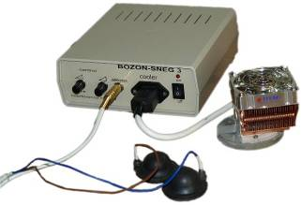 | Module "Bozon-SNEG-3"  Complete set:  The Module "BOZON-SNEG-3" is intended for strengthening of salin effect and controling painful reactions in patients during hypodermic injections of OOM by means of the combined influence of cold analgesia and influences of microcurrents. During tests it has shown a possibility of sharp increase in ozone concentration in hypodermic injections without strengthening pain of an injection. It is protected by patents of Ukraine and Russia.  Price for distributors: 810 $.
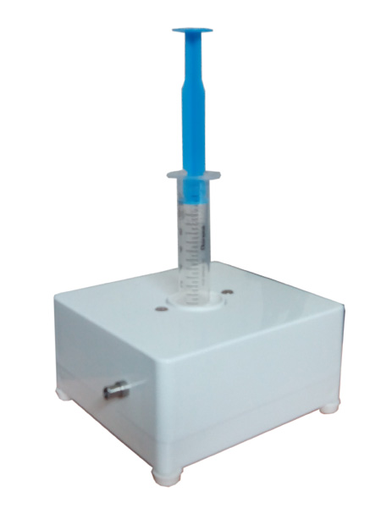 | Module "Bozon-PORT"  Complete set:  The Module "Bozon PORT " incorporates the valve from the ozone-resistant material allowing to fill a syringe with OOM quickly that substantially simplifies hypodermic injections of OOM. Stability of OOM concentration is achieved by a constant purging through the module, surplus of OOM gets into the destructor.  Price for distributors: 120 $.
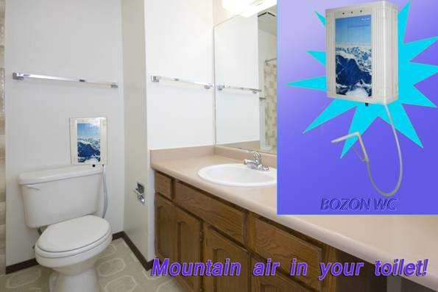  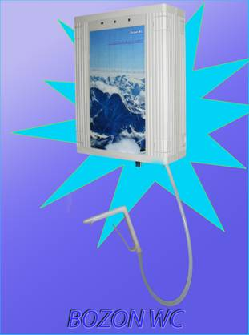 | “Home”  This ozonizer works for the total removal of bad smells of substances during defecation, and also in intervals between using a toilet. It has a gauge of position which automatically switches the ozonizer at the moment a person sits down on a toilet bowl. After that the ozone blows at the toilet bowl. The ozonizer can be used for water ozonization in a bath, disinfecting of bed-clothes, footwear and other purposes.  Price for distributors:200$.
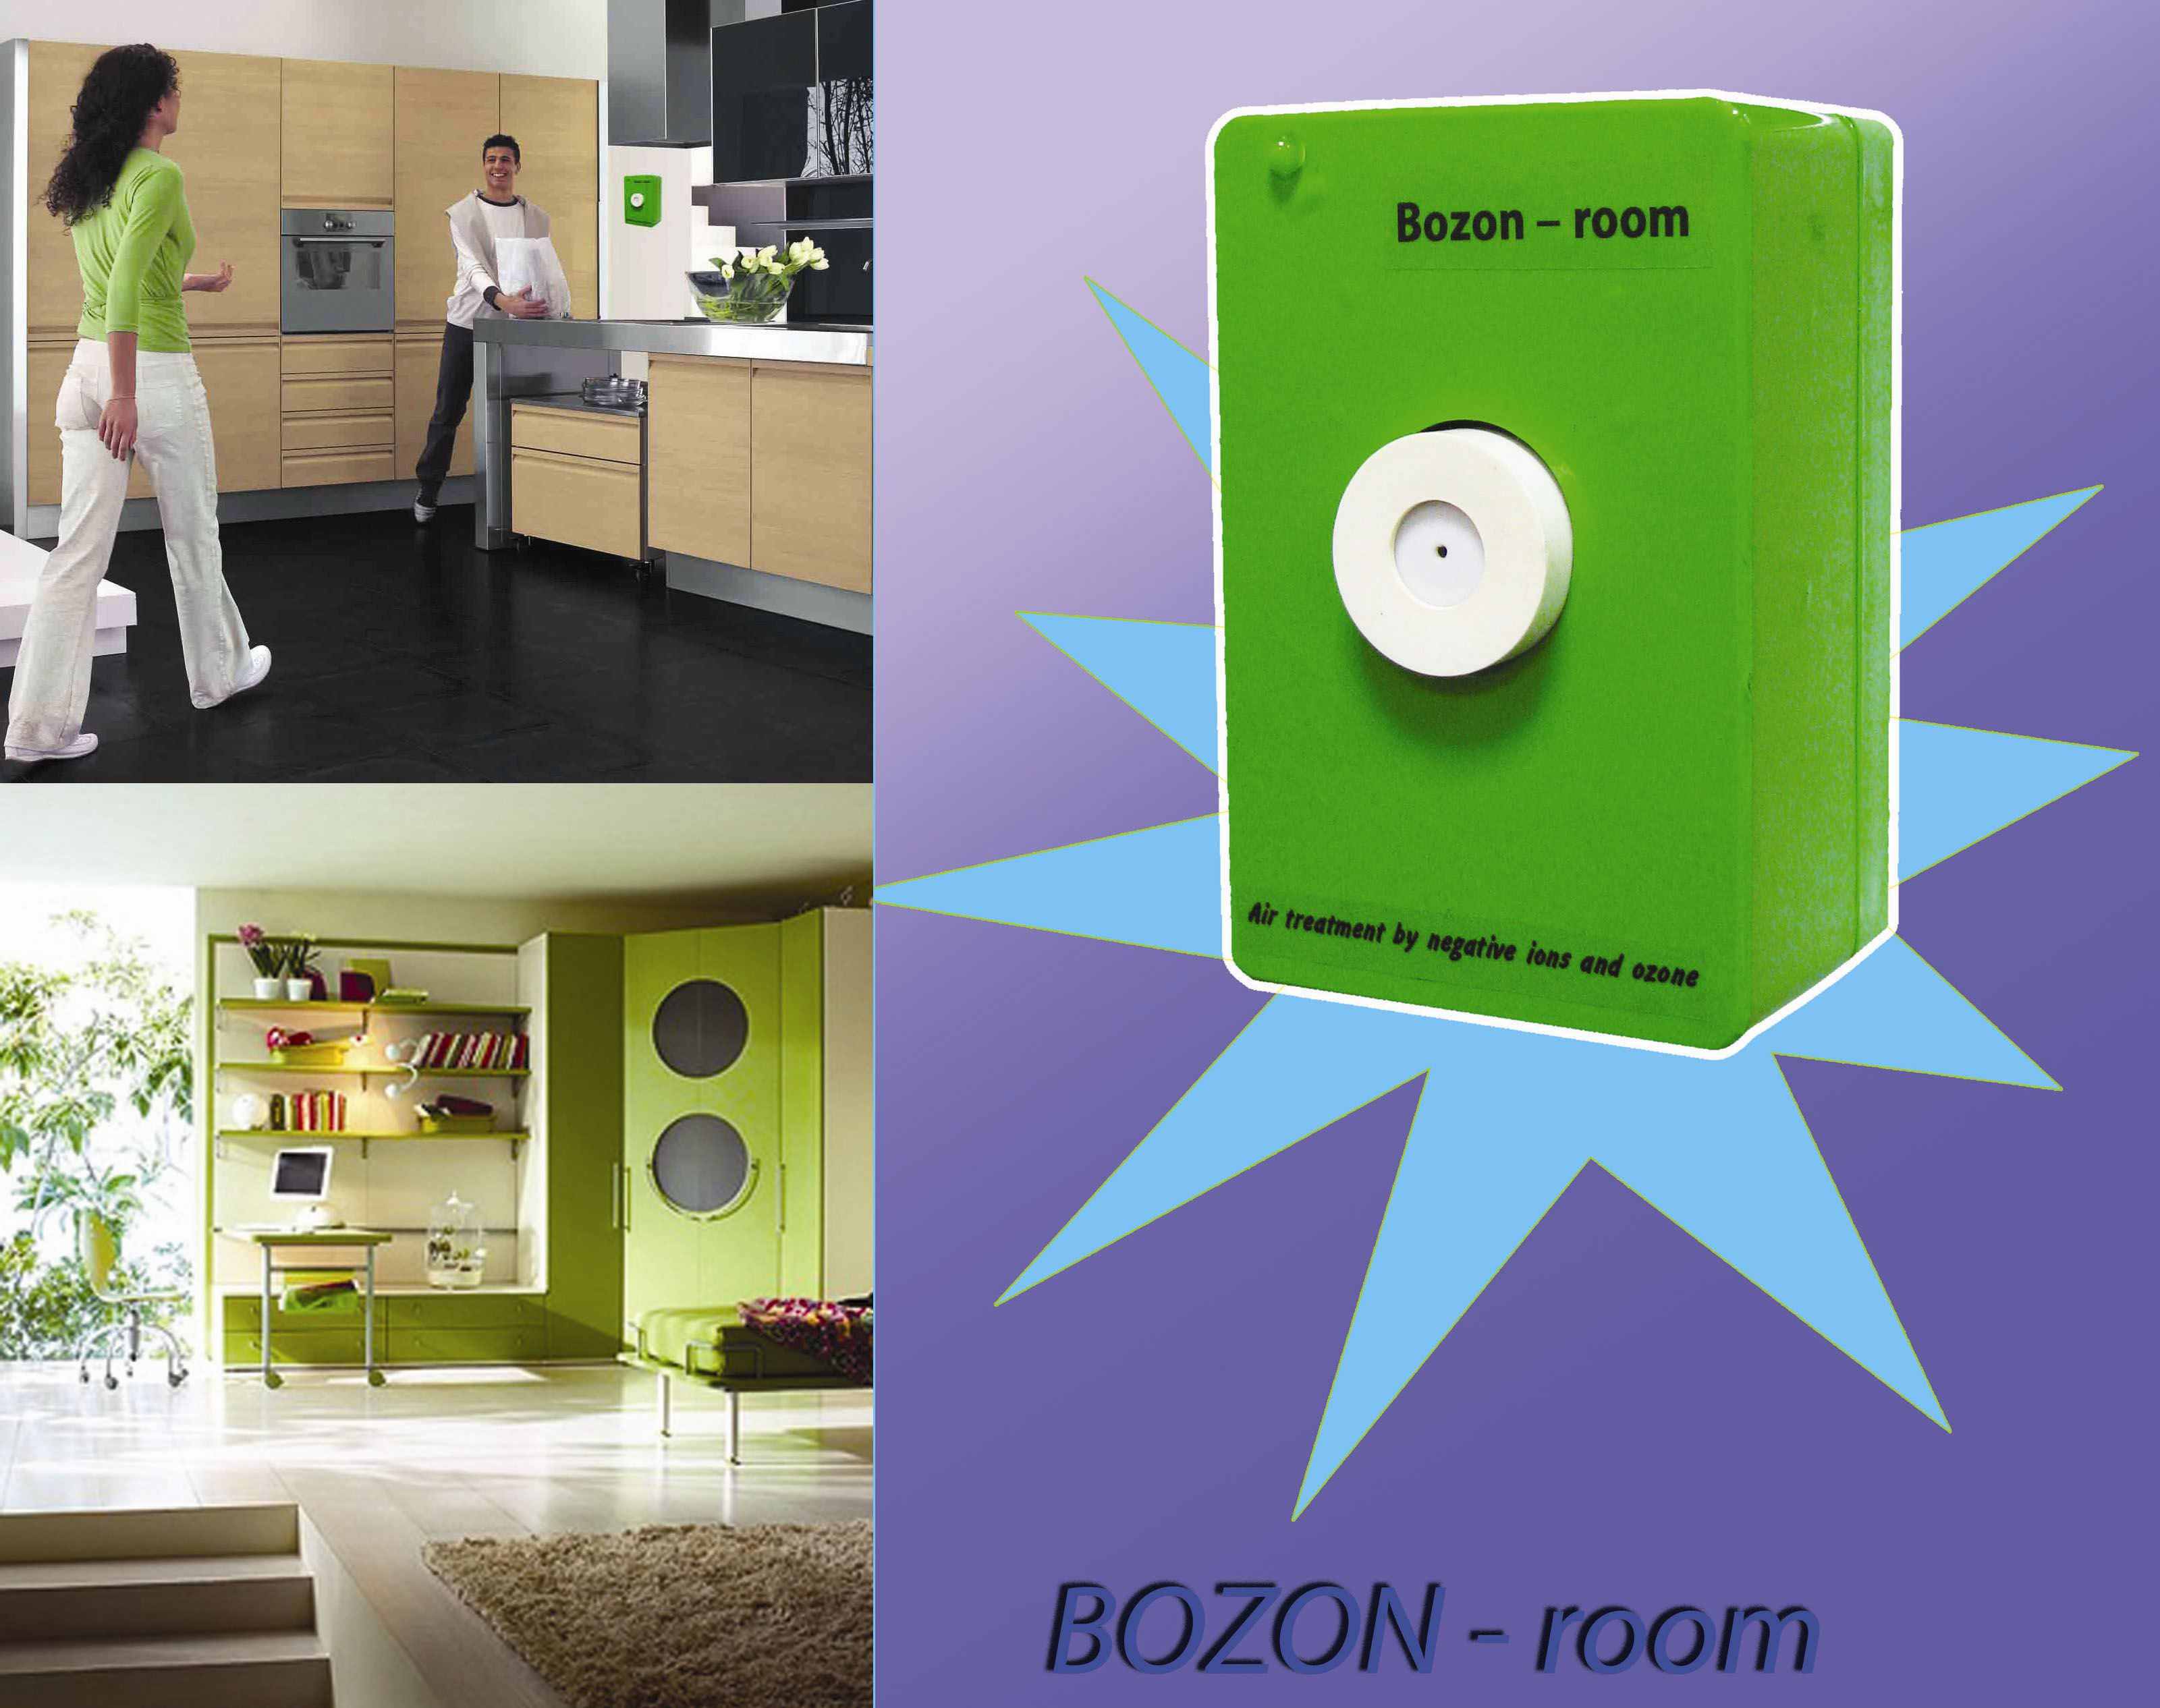 | Ozonizer-ionizer for an air conditioning in premises. Provides removal of the extraneous smells, harmful flying substances and of dust. It kills microorganisms and a mould. It is intended for continuous work.  Price for distributors: 140 $.

Auxiliary material:
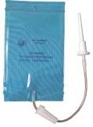 | Complete set for rectal ozonetherapy (rectal insufflation of ozone-oxigen mixture)  Price for distributors 4 $( MOK <120 pieces), 3$(MOK>=120 and >1000), 2.5$(MOK>1000).
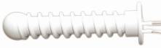  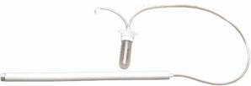 | Complete set for vaginal ozonetherapy “Bozon-VIN-100” (vaginal insufflation of ozone-oxigen mixture, pure ozonide oil or vaginal instillation of ozonized water)  Price for distributors 12 $(MOK<50), 10$(MOK>50 and <1000), 8$(MOK>1000).  Destructor ozone  Destructor ozone for carrying out of procedures in which are used “Bozon-VIN-100”  Prce for distributors 25$
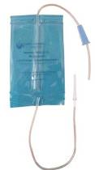 | Complete set for autohemotherapy major  Price for distributors 4$ (MOK<120), 3$(MOK>=120 and <1000),2,5$(MOK>1000)
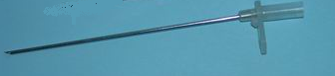  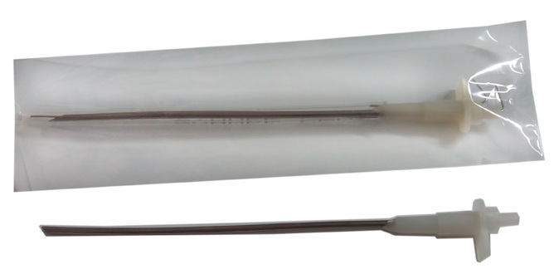 | Needle for preparation ozonized salin solution :  Needles for Bozon-N  Price for distributors 3$(MOK ≤100), 2$(MOK >=100),  Needles for Bozon-N+ (Europe)  Price for distributors 5$(MOK ≤100), 4$(MOK >=100), two channel needle for plastic bottle,  Needles for Bozon-N+ USA, Latin America –  Price for distributors 6$(MOK≤100), 4$(MOK>=100) three channel needle for glass bottle.

Products and sets based on use pure ozonides
 |  | Pure ozonides oil 25 ml:  OzonoVita Medium peroxide number = 400  Price for distributors 5 $ (MOK≤100) 4$( MOK >1000)  OzonoVita Forte peroxide number = 800  Price for distributors 10 $ ( MOK ≤100) 6$( MOK >1000)  OzonoVita SuperForte peroxide number = 1200  Price for distributors 14 $ ( MOK ≤100) 8$( MOK >1000)
  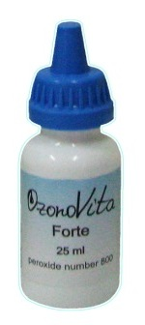 | 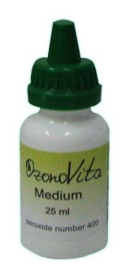 | 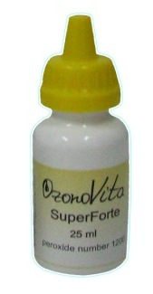
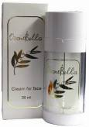 | Face cream (packaging in double-head airless bottle, 30 ml):  ”OzonoBella”  Price for distributors – 35$.
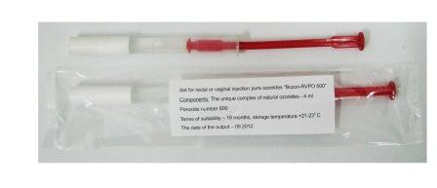 | Set for rectal or vaginal injection pure ozonides “Bozon- RVPO-600” (suppository)  Price for distributors 3$(MOK≤1000), 2$(MOK>1000)
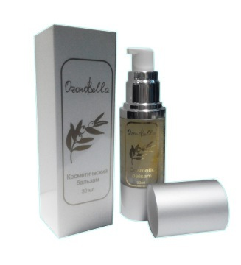 | Cosmetic balsam ”OzonoBella”  Price for distributors  100ml 30ml  70$ 30$
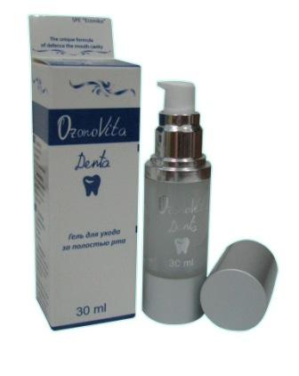 | Means for treatment of illnesses of gums (packaging in airless bottle):  “OzonoVita-Denta”  Price for distributors  100ml 30ml  65$ 25$
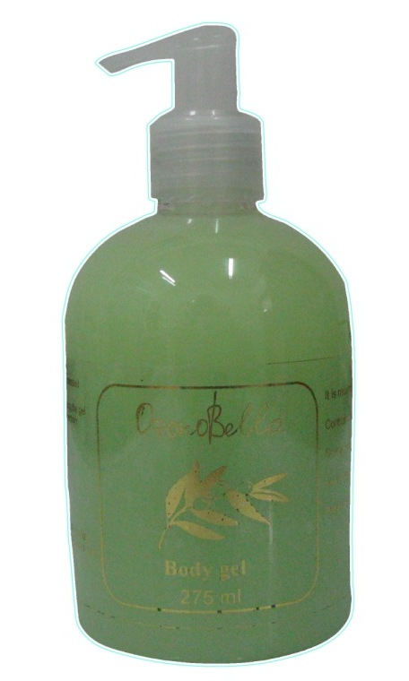 | Medical body gel ”OzonoBella”  Rich in ozonides, is created especially for a problem skin.  Price for distributors 6$
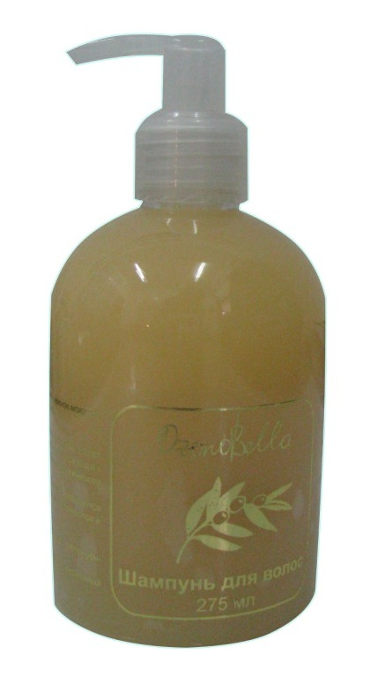 | Shampoo ”OzonoBella”  with ozonides is a soft washing material for dry and broken hair  275 ml  Price for distributors 6$
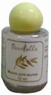 | Hair pack ”OzonoBella”  it prevents scurf formation, it restores hair structure.  25ml  Price for distributors 10$
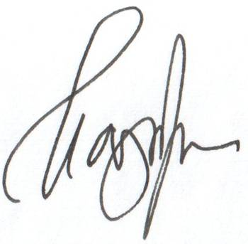
Prices trues before 1 Desember2018 CEO of SPE “Econika ”

Prof., Dr.Sci, Eugeny Nazarov

